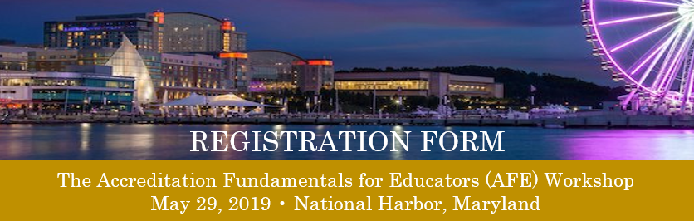

Registrant Information

Date

Name

Position/Title

Institution/Employer

Mailing Address

City State ZIP Code

Phone Mobile (optional)

Email Address

Registration Information

[ ] Check if attending the AFE Workshop Earn 8 CE credits for attending AFE
May 29, 2019, 8 a.m. - 5 p.m.

Registration fee = $250 per attendee [ ] Check if payment is enclosed
Registration and fees must be received by May 8, 2019

NEW! The ARC/STSA now accept credit card payments, log onto the registration page to pay by credit card. Or send completed registration form and check or money order to:
ARC/STSA
Attn: AFE Workshop
6 West Dry Creek Circle, Suite 110
Littleton, CO 80120

CANCELLATION POLICY

Cancellations must be received in writing by May 8, 2019
Refunds will be made 4-6 weeks after the AFE, minus a $50 processing fee
No refunds will be provided for cancellations after May 8, 2019

Accommodations

Gaylord National Resort & Convention Center
201 Waterfront Street
National Harbor, MD 20745
301-965-4000

Call the ARC/STSA at 303-694-9262 or email info@arcstsa.org

