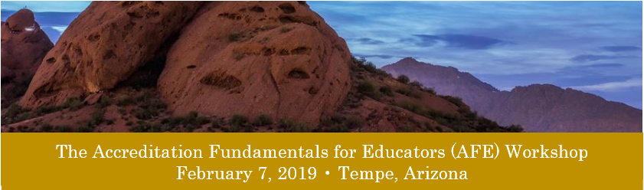
Registration Form

Registrant Information

Date Member/Cert/License #

Name

Position/Title

Institution/Employer

Mailing Address

City State ZIP Code

Phone Mobile (optional)

Email Address

Registration Information

[ ] Check if attending the AFE Workshop Earn 8 CE credits for attending AFE
February 7, 2019, 8 a.m. - 5 p.m.
[ ] Check if attending the Beginner/Refresher Site Visitor Training (SVT-B) Earn 2 CE credits for attending SVT-B
February 8, 2019, 3 - 5 p.m.
[ ] Check if attending the Advanced Site Visitor Training (SVT-A) Earn 1 CE credits for attending SVT-A
February 8, 2019, 5 - 6 p.m. (reserved for current, active site visitors)

Registration fee = $250 per attendee [ ] Check if payment is enclosed
Registration and fees must be received by January 10, 2019

Note: The ARC/STSA does not currently accept credit card payments. Please send completed registration form and check or money order to:
ARC/STSA
Attn: AFE Workshop
6 West Dry Creek Circle, Suite 110
Littleton, CO 80120

CANCELLATION POLICY

Cancellations must be received in writing by January 11, 2019
Refunds will be made 4-6 weeks after the AFE, minus a $50 processing fee

Accommodations

Double Tree by Hilton
2100 South Priest Drive
Tempe, AZ 85282
480-967-1441

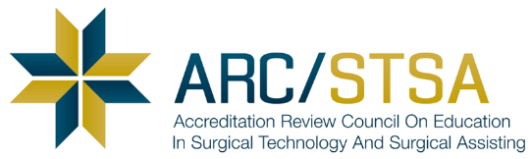
Call the ARC/STSA at 303-694-9262 or email info@arcstsa.org

