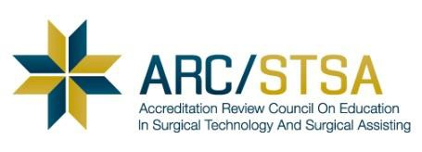
2015 CAAHEP-ARC/STSA Standards Implementation Notification

At the January 2015 CAAHEP meeting, the Board of Directors made a change to Standard V.A.4 in the accreditation Standard for all of its healthcare professions.

V. Fair Practices
A. Publications and Disclosure
4. The sponsor must maintain, and make available to the public current and consistent summary information about student/graduate achievement that includes the results of one or more of the outcomes assessments required in these Standards.
Guideline: The sponsor should develop a suitable means of communicating to the communities of interest the achievement of students/graduates (e.g. through a website or electronic or printed documents).
For programs to be in compliance with the new Standard the following change must be implemented:

All programs must publish the approved Outcomes Assessment Exam (OAE) pass-rate from the program’s most recently submitted Annual Report. These results must be made available to the public using at least one of the following methods:
- Institutional website
- Annual catalog
- Programmatic documents
- Other publicly distributed publications

At all times the published pass-rate must be consistent with and verifiable by the program’s most recently submitted Annual Report.

School Name (full) ____________________________________________________________________

Program Director’s Name PD Signature Date

Institutional Administrator’s Name/Title Administrator Signature Date

Please return this signed document as a PDF attachment to an e-mail sent to lucinda.martinez@arcstsa.org, or by fax to:303-741-3655 at the ARC/STSA office on or before September 30, 2015.
[NOTE: If sent by fax, the program is responsible for confirming receipt by contacting the ARC/ STSA by email to lucinda.martinez@arcstsa.org or by phone at (303) 694-9262.]

Programs that do not submit the CAAHEP-ARC/STSA STANDARDS NOTIFICATION on or before September 30, 2015 due date will be assessed a $250 late fee, consistent with the ARC/STSA policy (please refer to the ARC/STSA Schedule of Fees, available online at www.arcstsa.org/wp-content/uploads/2013/10/2014-2015-Schedule-of-Fees.pdf).

Please contact the ARC/STSA office at 303-694-9262 or info@arcstsa.org with any questions.

